**PUP Application For Re-Admission Form**

**Members:**

Mijares, Jaira C

Porlares, Alexander S.

**Github Repository:** <https://github.com/Rednaxela5/PUP-AFRA-Form>

**Timeline:**

* **October 24, 2023**
  + Selection of manual form that will be converted into website.
  + Task 1
  + 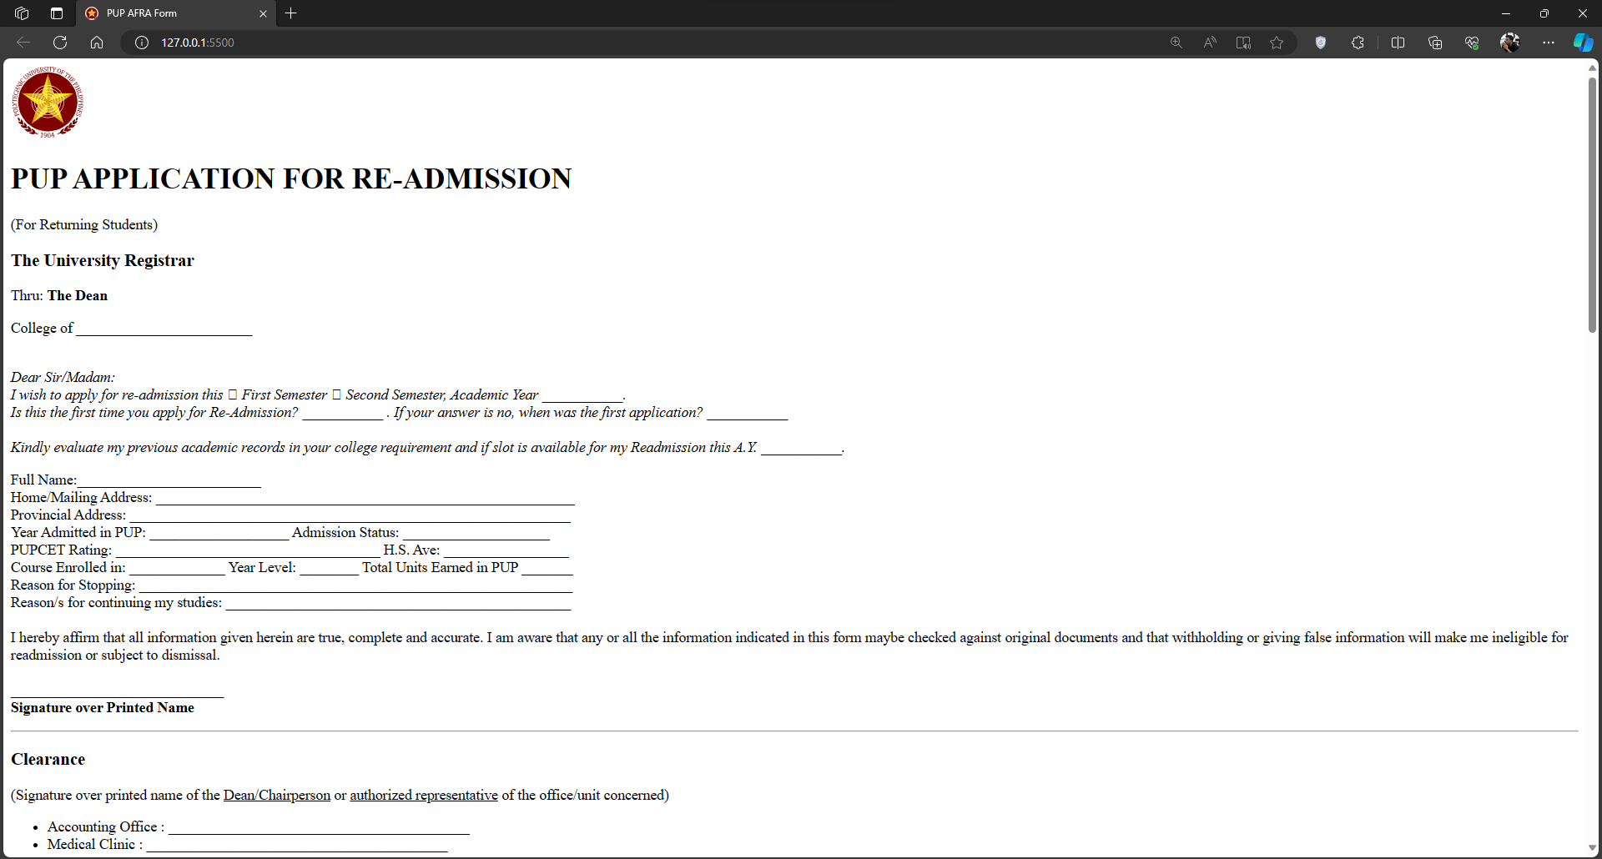Initial setup of the repository and website.

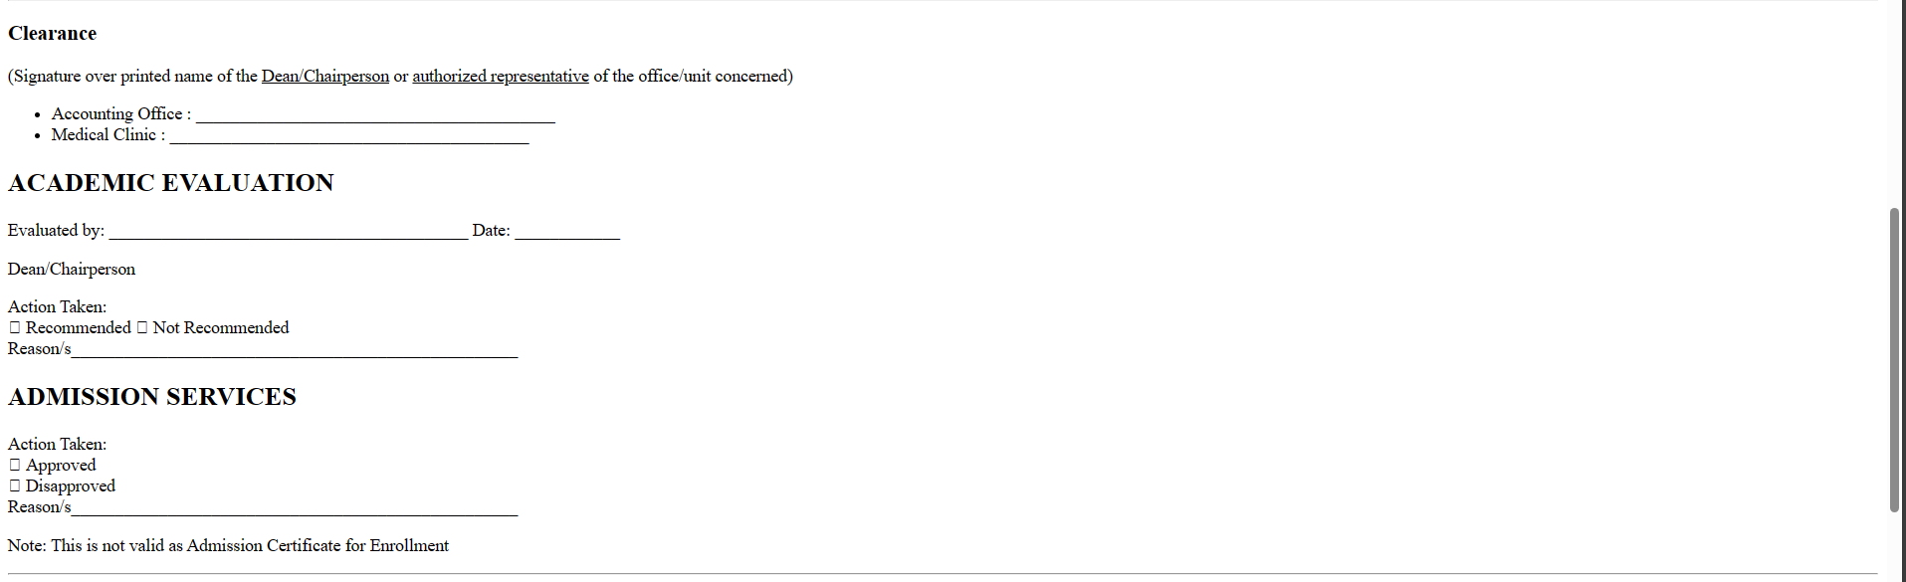

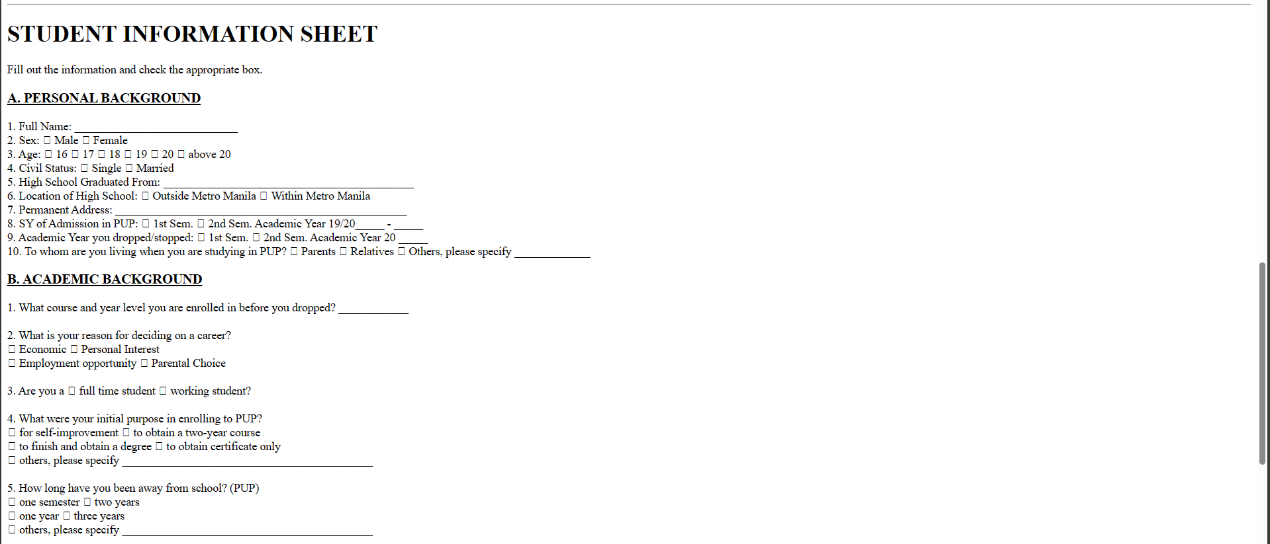

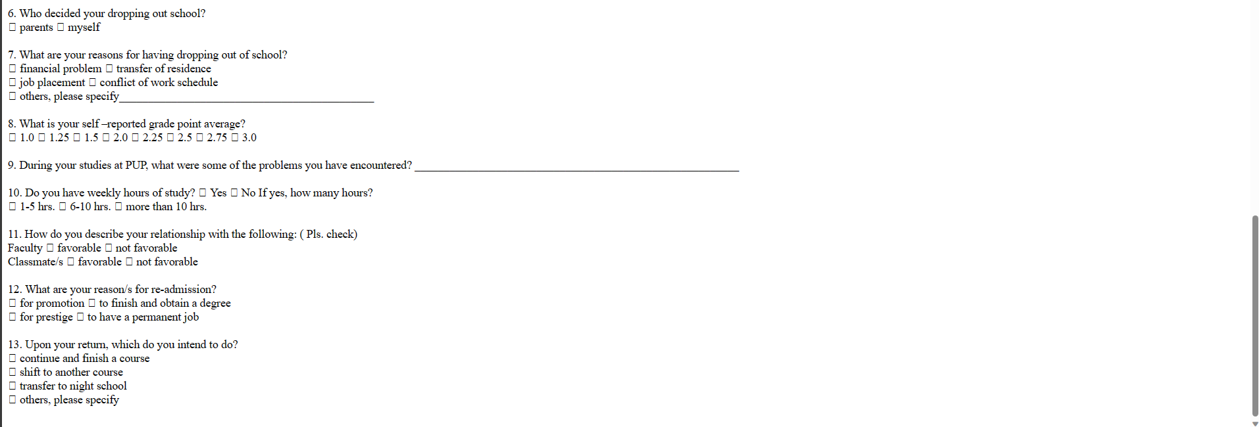

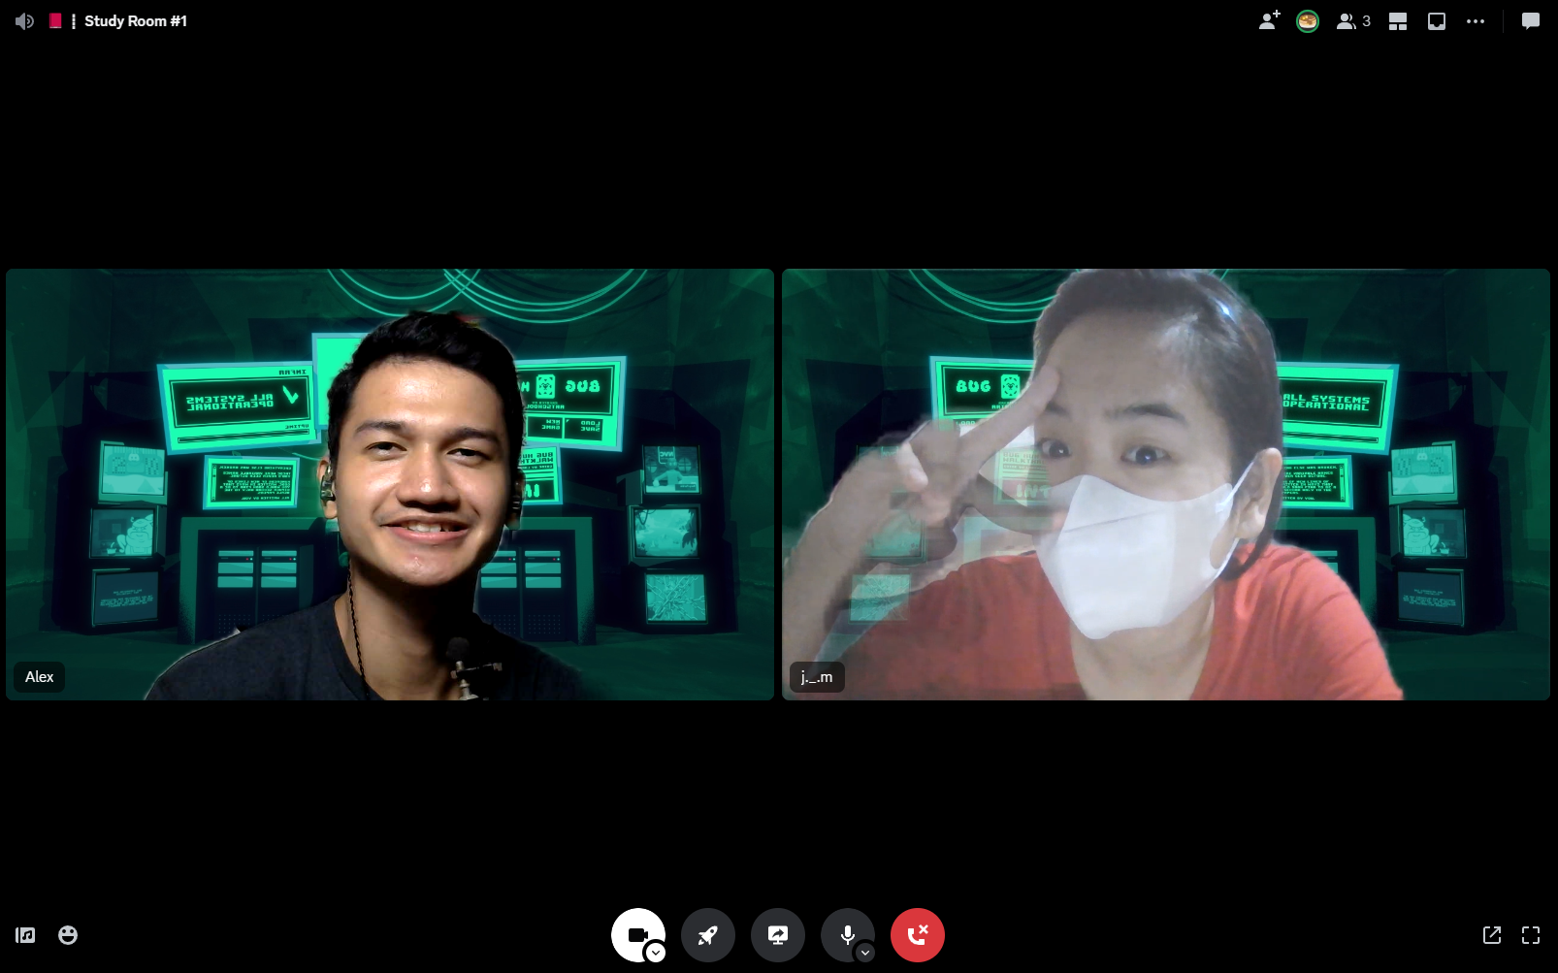

* **October 31, 2023 (8:30 PM – 2:00 AM)**
  + Setup and Learned Figma.
  + Compiled the resources needed for design (color palette, pictures, font styles, design ideas)
  + Design the website in Figma.

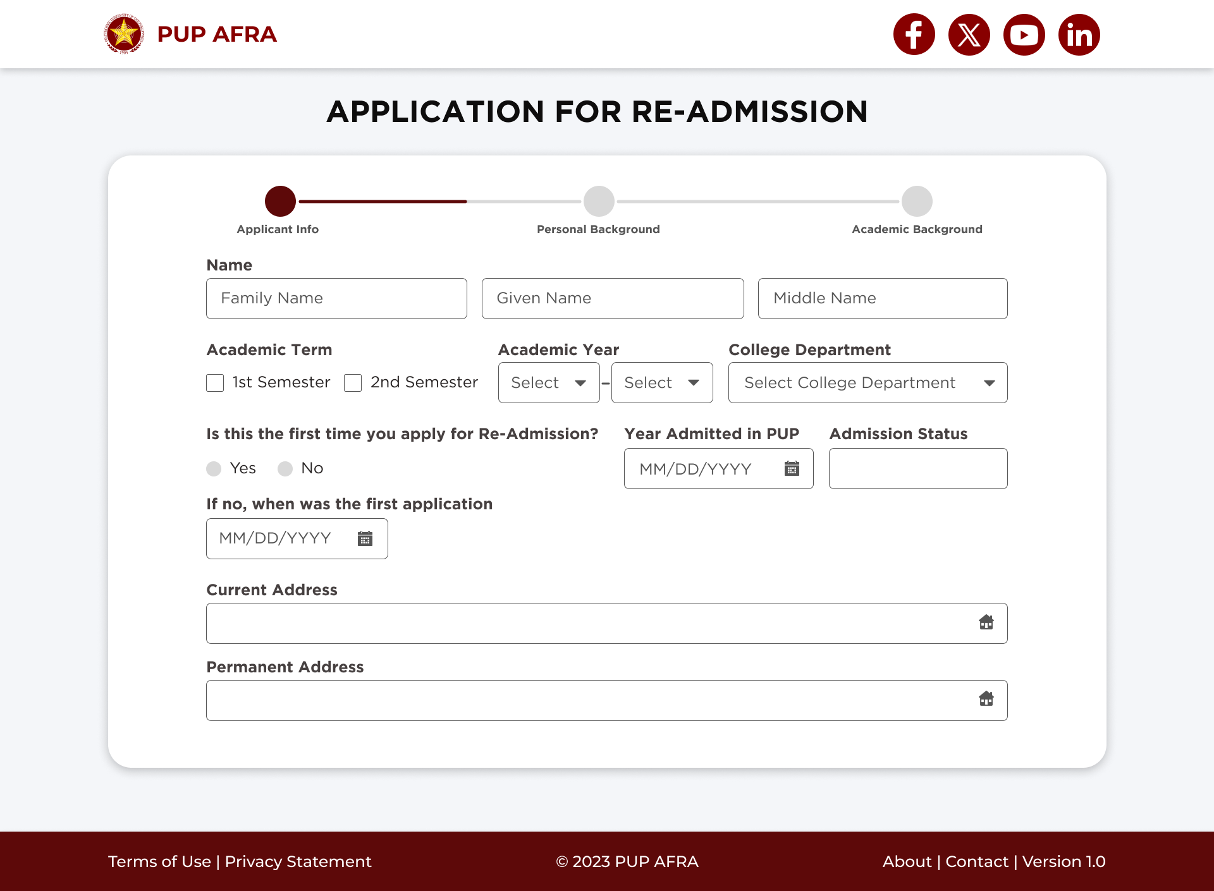

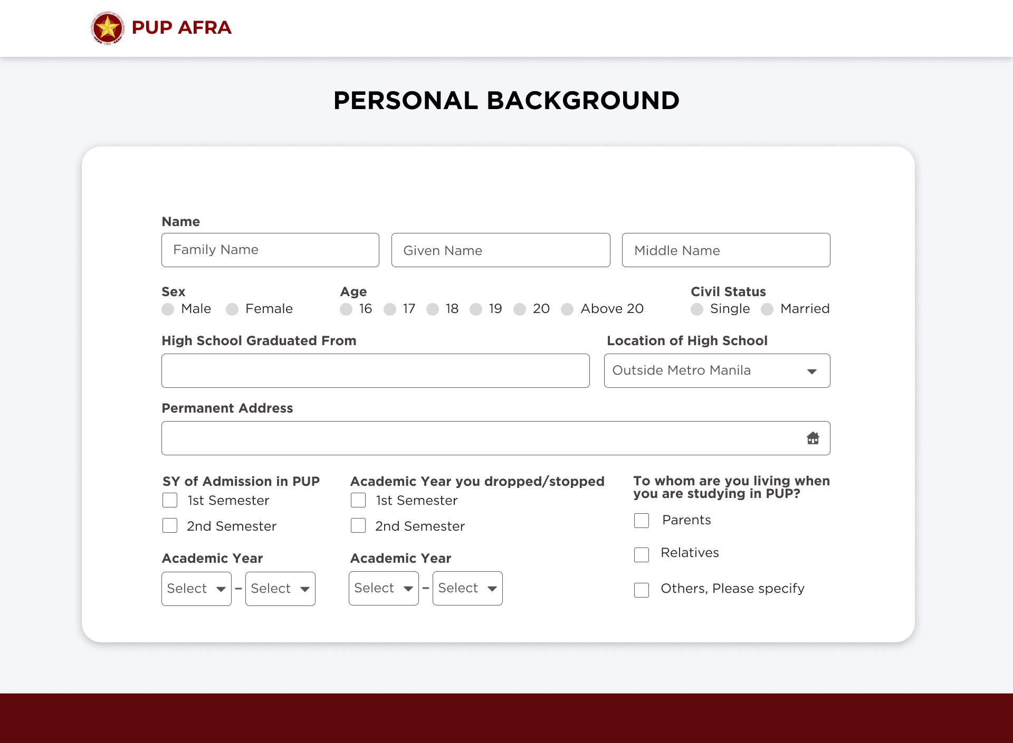

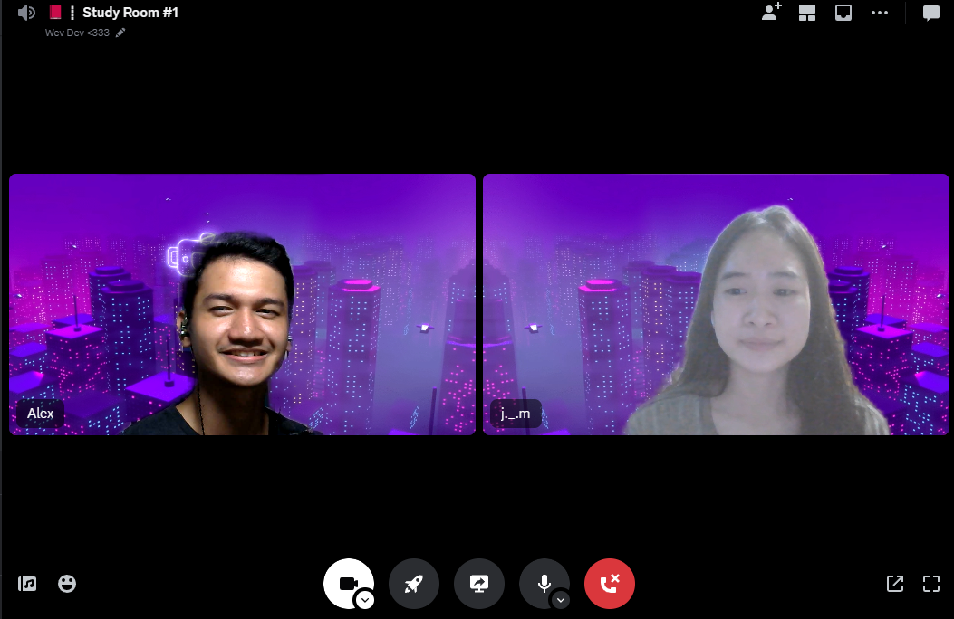

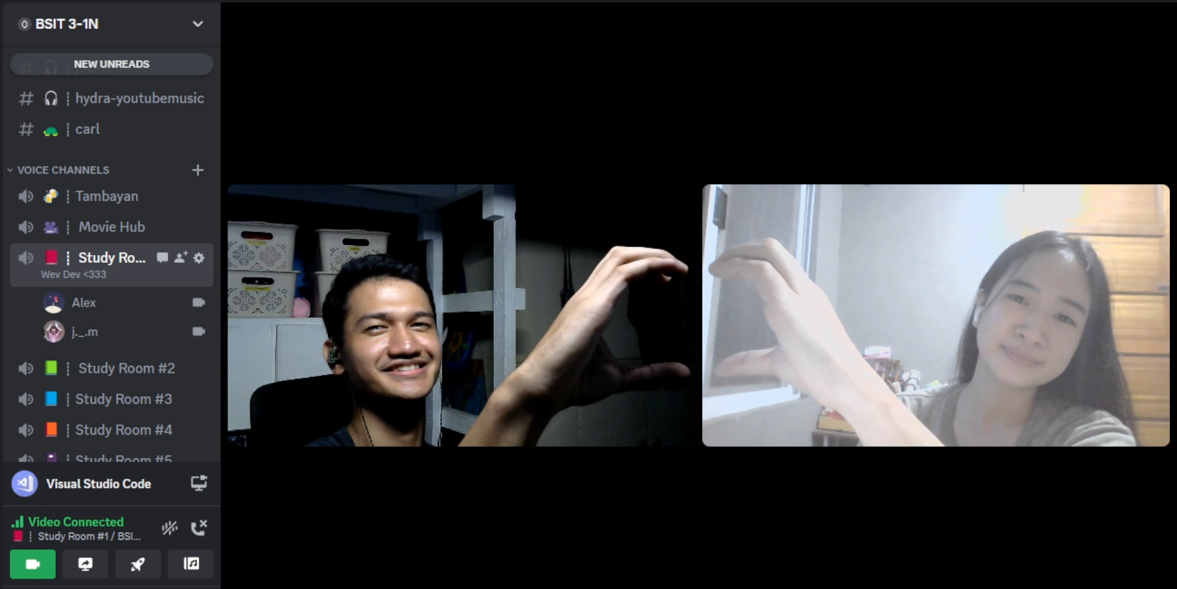

* **November 07, 2023 (9:15 PM – 3:00 AM)**
  + Continue designing the website in Figma.
  + Brainstorm ideas on what approach can be made in address. (Found out Philippine Address Locator: <https://github.com/wilfredpine/philippine-address-selector>) – it uses Location API
  + **Next Step:**
* Home Page (Design)
* Thank You Page (Design)

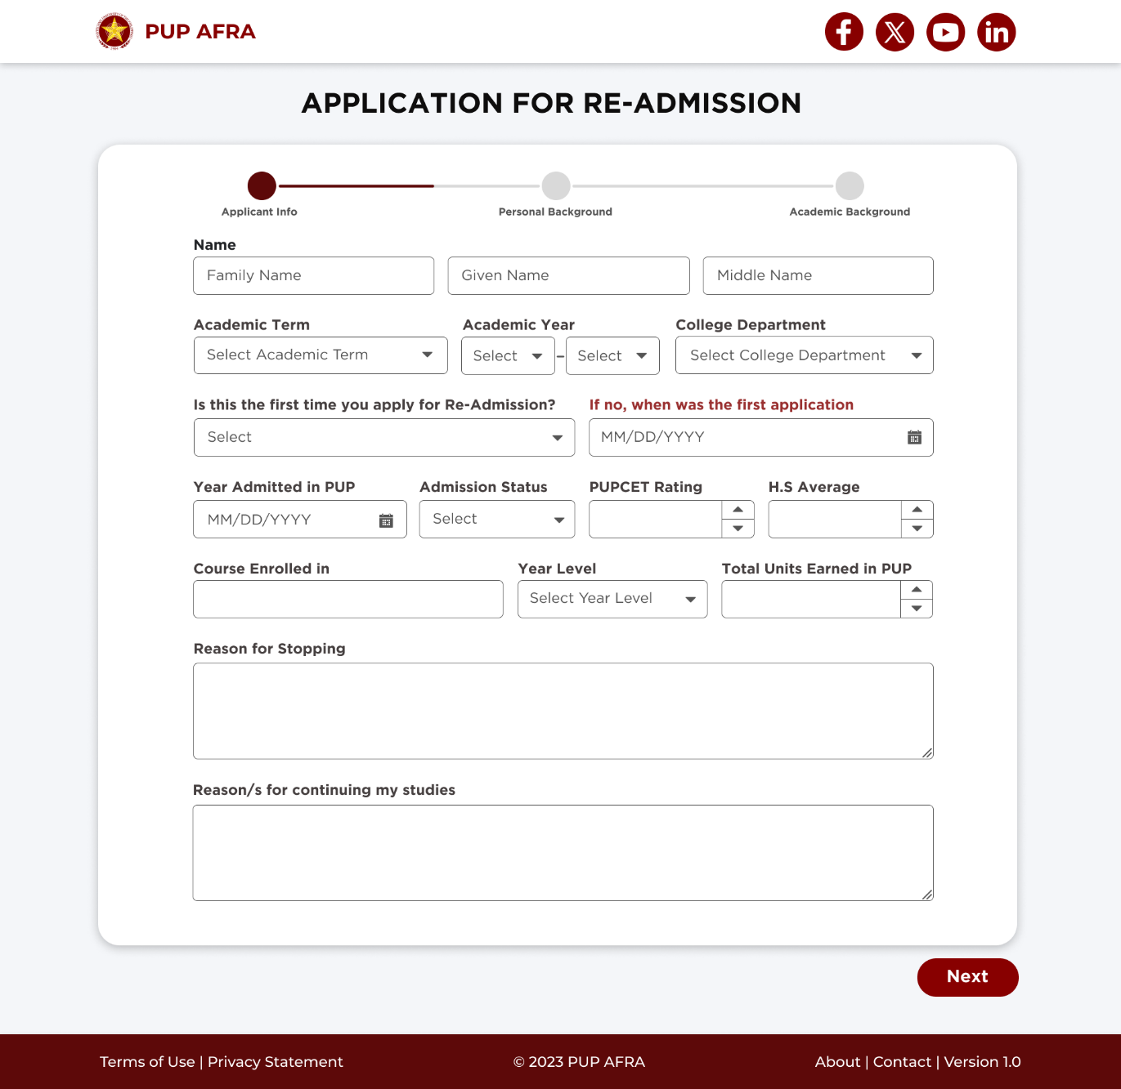

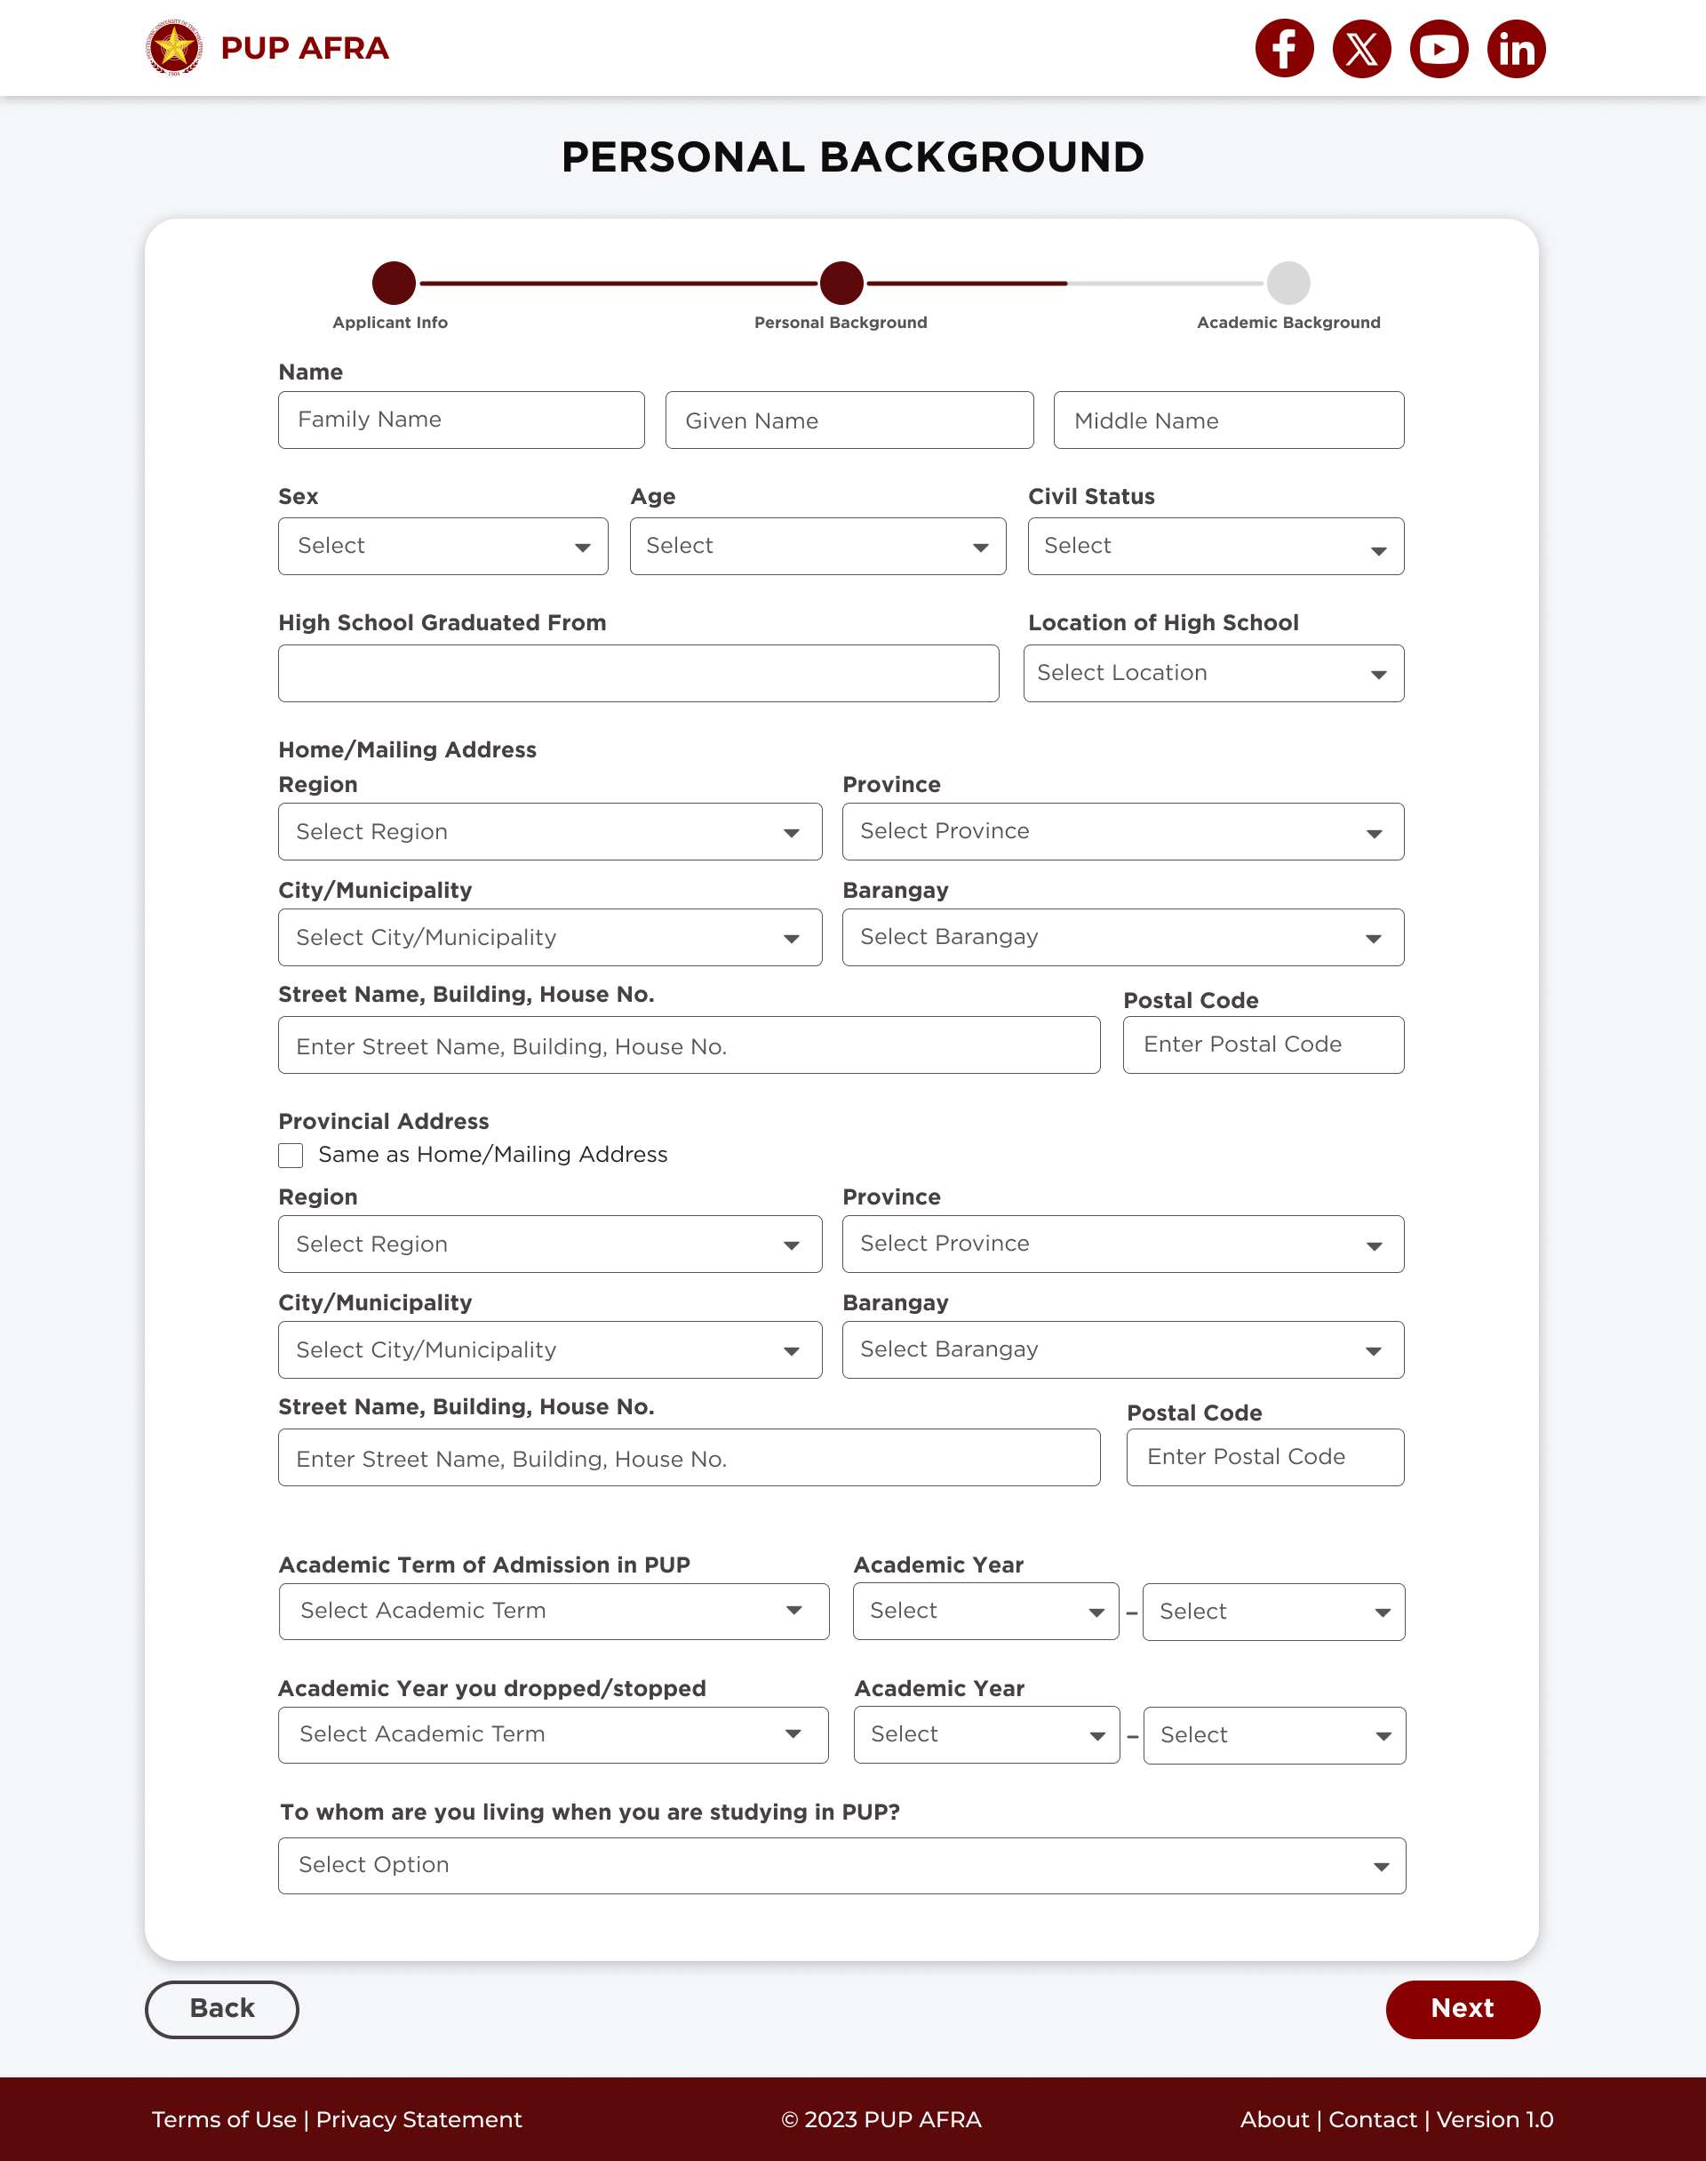

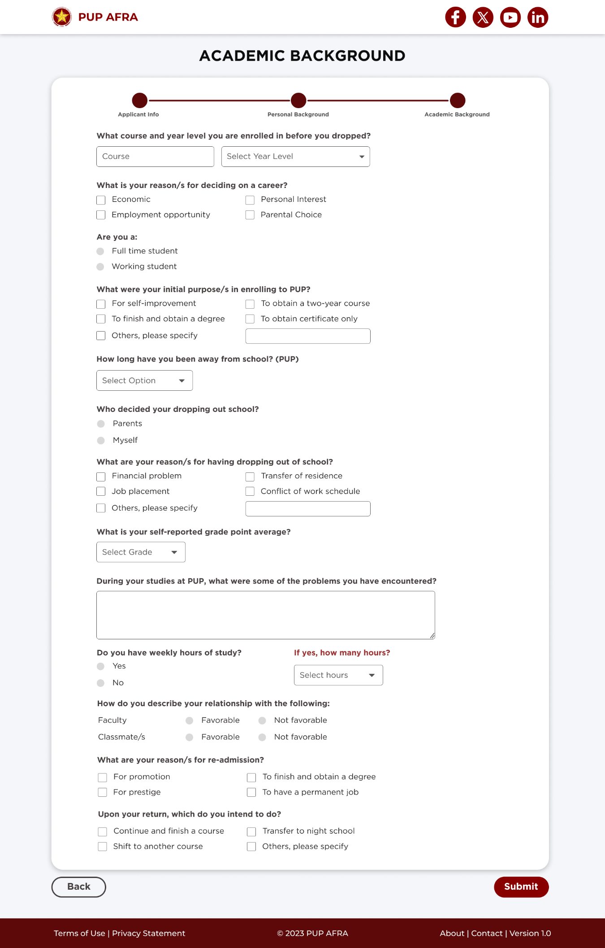

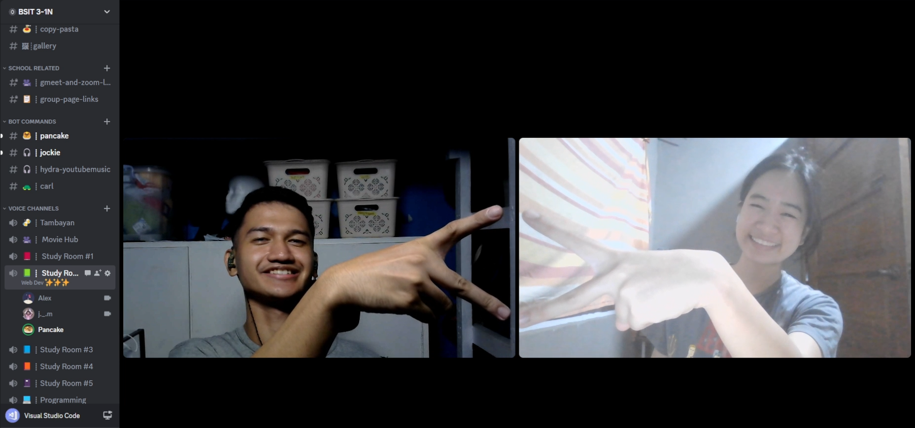

* **November 14, 2023 (9:00 PM – 1:50 AM)**
  + Continue designing the website in Figma.
    - Finished “Thank You Page” Design
    - Continue making “Homepage/Landing Page” Design
  + Used Canva for editing pictures for the homepage.
  + Made a basic prototyping in figma to simulate the next, back, return home buttons.
  + **Next Step:**
* Finalize the Home Page
* Optimize the process of application (manual-digital)
* Documents Submission Page (Design)

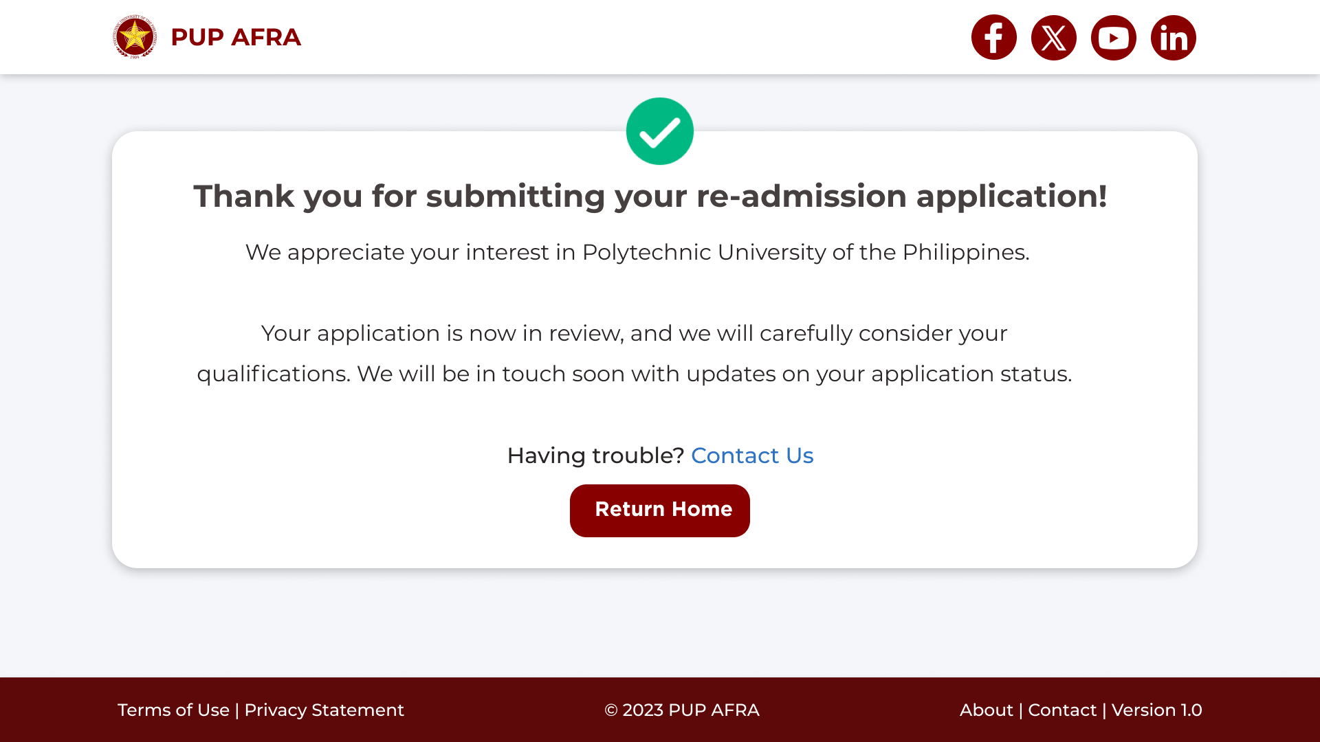

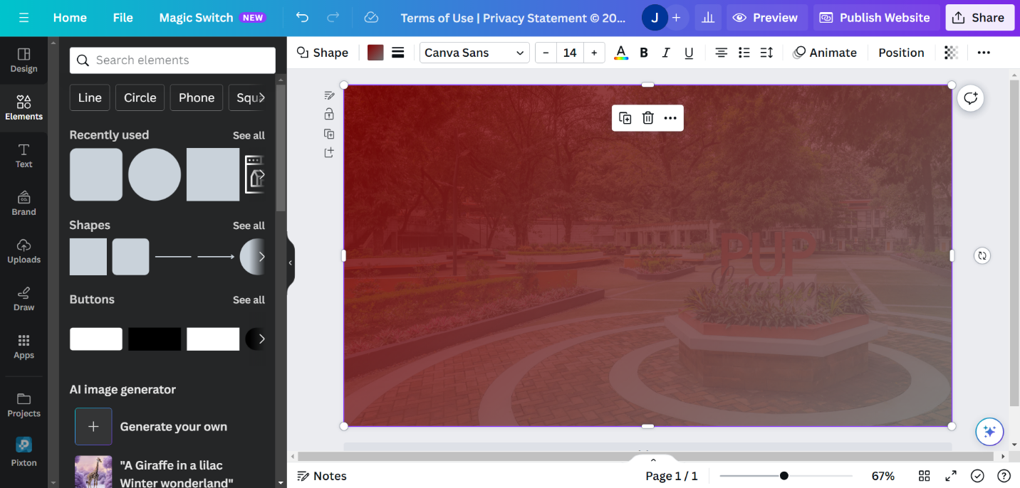

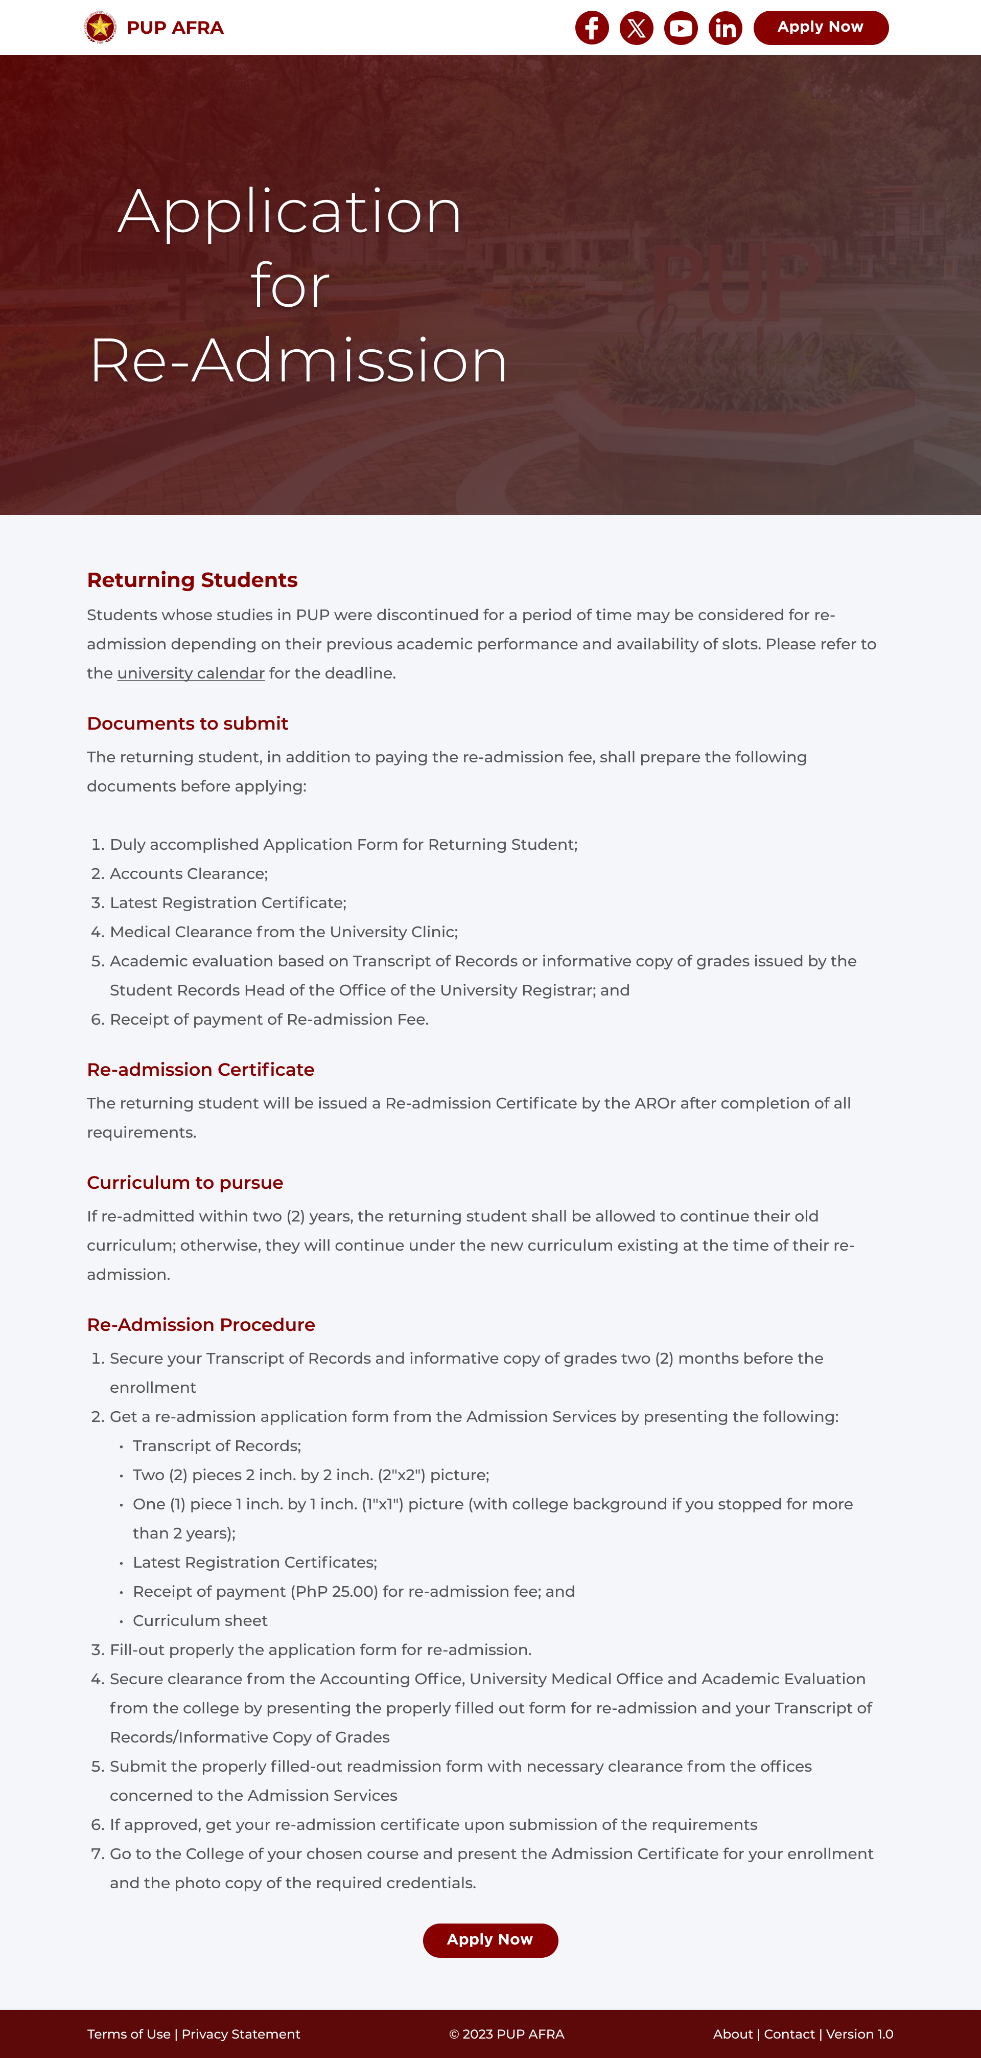



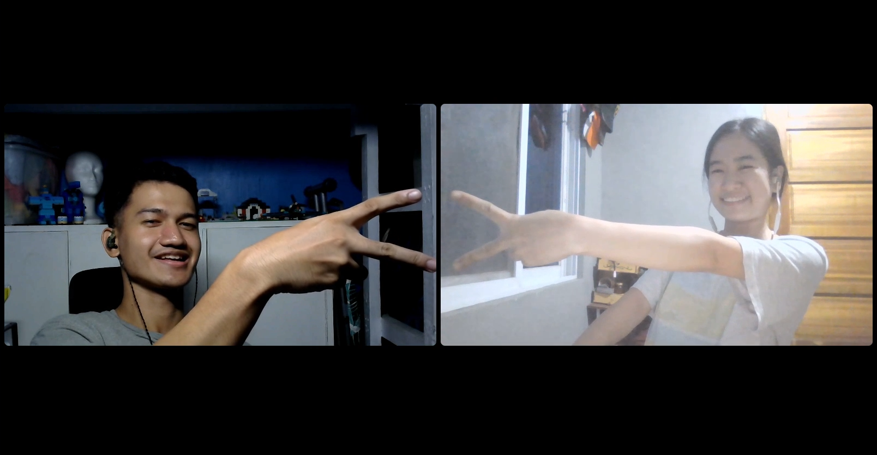

* **November 21, 2023 (5:00 PM – 11:00 PM)**
  + Continue designing the website in Figma.
    - Finished “Home Page” design.
    - Finished “Upload Documents” design.
    - Initialize “About Page” design.
    - Added “TOP” button. Its purpose is to go to back to top once clicked. Also learned how to make the hover effect.
    - Modified the “back”, “next”, and “submit” button.
    - Modified the progress bar design because of the added “Upload Documents” page.
  + Used Canva for editing pictures for the homepage.
  + Enhance the prototyping experience for wireframes.
  + **Next Step:**
    - Consultation for the feasibility of the project (Nov. 28, 2023).



